**6.3 Periodic Trends**

**IDX G9 Chemistry S STUDY GUIDE ISSUE 5**

**By Emma**

* Many properties of the elements change in a predictable way as you move through the period table, and these systematic variations are called periodic trends

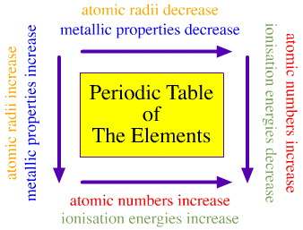

I. Trends in Atomic Size

* The atomic radius is one-half of the distance between the nuclei of two atoms of the same element when the atoms are joined
* The atomic radius is often measured in picometers (pm).

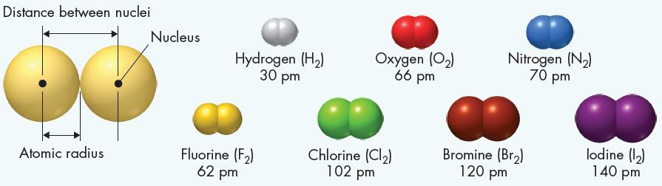

* The attraction force between electrons and nucleus will affect many atom’s properties

1. For outmost electrons in principle energy level with quantum number n, the attraction will decrease as n increases.

eg: Li > Na > K > Rb > Cs (group 1)

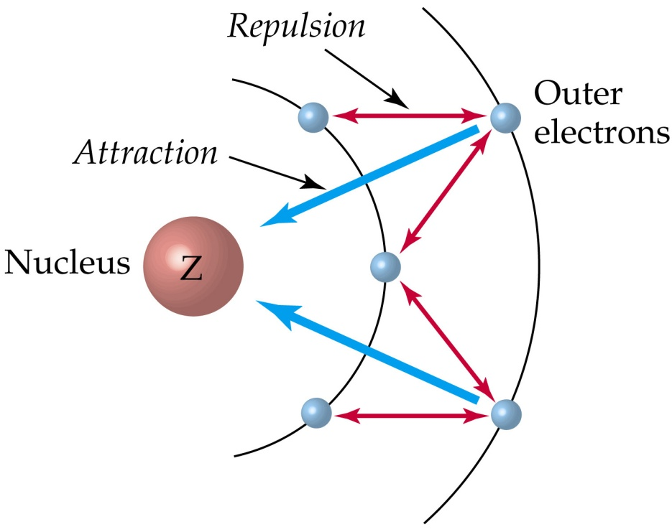

2) If the outmost electrons are in the same principle energy level, the attraction will increase as proton number increases.

eg: Na < Mg < Al < Si < P < S < Cl (period 3)

* Trend 1: Atoms get larger going down a group.
* Going down a group = more energy levels, attraction decrease = outmost electrons go further, size increase
* Trend 2: Atoms get smaller moving from left to right across each period.
* Moving from left to right = same energy level, more protons, attraction increase = outmost electrons closer, atom size decrease

II. Trend for Ionic Size

* An ion is an atom or group of atoms that has a positive or negative charge
* An ion with a positive charge is called a cation (metal easy to lose electrons)
* An ion with a negative charge is called an anion (nonmetal easy to gain electron)
* Octet rule: Atoms tend to gain, lose, or share electrons in order to acquire a full set of valence electrons

卡通人物

AI 生成的内容可能不正确。

* For most energy levels, there are 8 valence electrons in a full set of valence electrons --- 2 in s orbital and 6 in p orbitals
* An exception for the first energy level, which is full with only 2 electrons
* The elements on the right side of the periodic table tend to gain electrons – or become anions – in order to acquire a complete set of valence electrons (being stable)
* The elements on the left side of the periodic table tend to lose electrons – or become cations – in order to acquire a complete set of valence electrons (being stable)
* Noble gases neither gain nor lose electrons
* Positive Ions (lose electrons) become smaller, because the repulsion between electrons is reduced, radius of a cation is smaller than an atom
* Negative Ions (gain electrons) become larger, because the repulsion between electrons is increased, radius of an anion is larger than an atom
* Trend 1: Ions get larger going down a group
* Trend 2: Ions get smaller from left to right
* The anions in same period and cation of next period have same number of electrons but proton number is increasing in nucleus, thus the attraction force increases and ion sized decreases
* Trend 3: For same elements, the one with less electrons (more positive or less negative) is smaller

III. Trend for Ionization Energy

* An atom’s ionization energy (I) is the energy needed to remove one of its electrons
* Atoms with high I hold onto their electrons tightly, whereas atoms with low I are more likely to lose outmost electrons
* Trend 1: Ionization energies decreases as you move down a group (more energy level, far away from the nucleus)
* Trend 2: Ionization energies increases as you move from left to right across a period (ions get smaller so nearer to the nucleus so more energy is required to remove electrons)
* Ionization energy trends are exactly opposite of the trends for atomic radius, and radius is inversely proportional to attraction while ionization energy is proportional to attraction

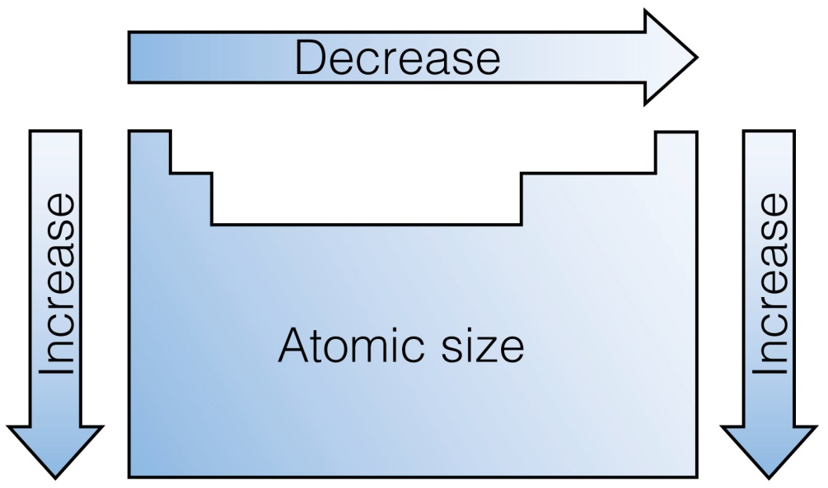 图表, 箭头, 直方图

AI 生成的内容可能不正确。

* The successive ionization energies are the energies required to remove electron beyond the first electron
* Trend 3: the ionization energies increase for every electron removed

表格

AI 生成的内容可能不正确。

* An atom holds the electrons in its noble gas inner core much more strongly than it holds its valence electrons, so there is a large increase when the atom begins to lose the inner electron

IV. Trend for Electronegativity (EN)

* Electronegativity is the ability of an atom of an element to attract electrons when the atom is in a compound.

[表格

AI 生成的内容可能不正确。](../../../资源/Portfolio/7%20Periodic%20Properties%20of%20Elements/PerTrendsElectronegativity.mov)

* Electronegativity values have no units and is neither energy ro a property that can be directly measured
* Electronegativity: nonmetal > metal
  1. **Ions**
* The forces that link atoms together to form the different kinds of matter are called chemical bonds

I.Valence Electrons

* Valence electrons are the electrons in the highest occupied energy level of an element’s atoms
* Exception: helium have two valence electrons, and other noble gases have eight valence electrons
* To find the number of valence electrons in an atom of a representative element, simply look at its group number
* Electron dot structures are diagrams that show valence electrons in the atoms of an element as dots
* All the electrons with a given group (with the exception of helium have the same number of electron dots in their structures)
* 表格

  AI 生成的内容可能不正确。
* Electron dot structure will be used to show how chemical bonds form in chemical reaction

II. The Octet Rule

* Noble gases, such as neon and argon, are nonreactive in chemical reactions
* Atoms of each of the noble gases (except helium) have eight electrons in their highest occupied energy levels and the general electron configuration of ns^2np^6
* The octet rule states that in forming compounds, atoms tend to achieve the electron configuration of a noble gas
* Atoms of metal tend to lose their valence electrons, leaving a complete octet in the next-lowest energy level
* Atoms of some nonmetals tend to gain electron or share electrons with another nonmetal atom or atoms to achieve a complete octet
* The octet rule applies to atoms in most compounds

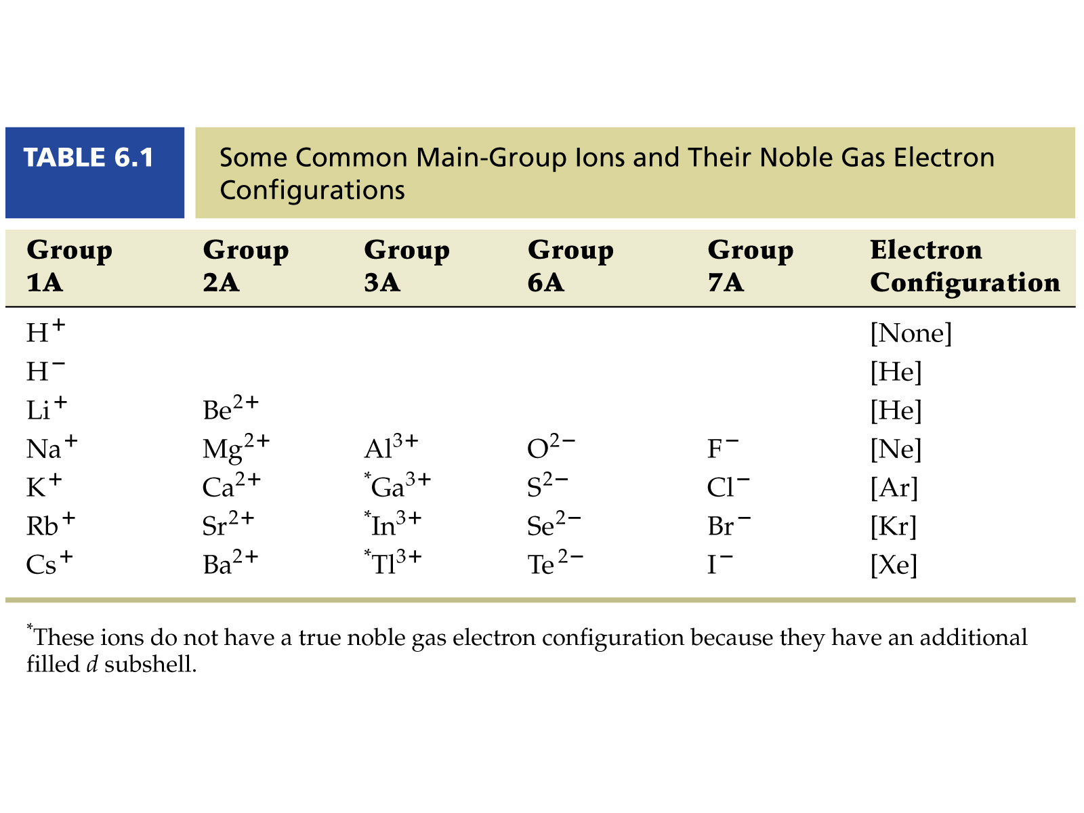

III. Formation of ions

* Ion – an atom that is no longer neutral because it has lost or gained electrons
* A positively charged ion, or cation, is produced when an atom loses one or more valence electrons
* A negatively charged ion, or anion, is produced when an atom gains one or more valence electrons

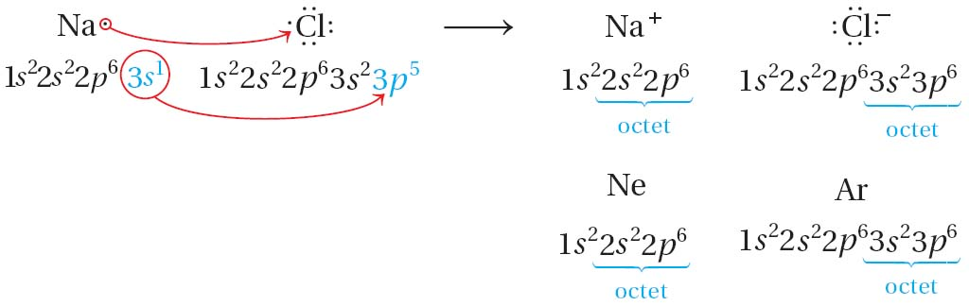

文本, 表格

AI 生成的内容可能不正确。

* The name of the anion typically ends in -ide.
* The ions produced when atoms of chlorine and other halogens gain electrons are called halide ions
* Transition Metal Cations
* The charges of cations of the transition metals may vary

表格

AI 生成的内容可能不正确。

* 1. **Ionic Bonds and Ionic Compounds**

1. Formation of Ionic Compounds

* An ionic compound is a compound composed of cations and anions
* Although they are composed of ions, ionic compounds are electrically neutral
* If ionic bonds occur between metals and the nonmetal oxygen, oxides form
* Most other ionic compounds are called salts
* Binary ionic compounds contain a metallic cation and a nonmetallic anion

图形用户界面

AI 生成的内容可能不正确。

* Ionic compounds are electrically neutral, so the charges of cations and anions must be balance

文本

AI 生成的内容可能不正确。

手机屏幕截图

AI 生成的内容可能不正确。

* The electrostatic forces that hold ions together in ionic compounds are called ionic bonds
* A chemical formula shows the numbers of atoms of each element in the smallest representative unit of a substance
* A formula unit is the lowest whole-number ratio of ions in an ionic compound
* For sodium chloride, the lowest whole-number ratio of the ions is 1:1 (one Na+ ion to each Cl- ion)
* Although ionic charges are used to derive the correct formula, they are not shown when you write the formula unit of the compound. 🡪 The formula unit of sodium chloride is NaCl.

图示, 形状, 圆圈

AI 生成的内容可能不正确。

* The coordination number of an ion is the number of ions of opposite charge that surround the ion in a crystal
* In NaCl, each ion has a coordination number of 6.
* The coordination number of Na+ is 6 because each Na+ ion is surrounded by six Cl- ions.
* The coordination number of Cl- is also 6 because each Cl- ion is surrounded by six Na+ ions.

1. Properties of ionic compounds

* Most ionic compounds are crystalline solids at room temperature
* The component ions in such crystals are arranged in repeating three-dimensional patterns
* Each ion is attracted strongly to each of its neighbors, and repulsions are minimized
* Property 1: the large attractive forces result in a very stable structure
* Property 2: the network of attractions that extends throughout an ionic crystal gives these compounds their high melting point.
* Property 3: Ionic crystals are strong, but brittle.
* When ionic crystals are struck, the cations and anions are shifted from their fixed positions. Repulsions between ions of like charge cause the crystal to shatter.
* Property 4: Ionic solid is poor conductor. But it can conduct electricity in molten (liquid) state and aqueous state (dissolved in water)
* Ions has fixed position in solid state without freedom to move around
* Ionic compounds can conduct an electric current when melted or dissolved in water.
* When they melted, the orderly crystal structure breaks down. When dissolved, the ions are free to move about in the solution.